Market Name: ________________________________________________________

These questions may be entered directly into the toolkit excel file.
Please take special care to answer the questions in bold.

- Please complete simplified Profit and Loss Statement in toolkit excel file.

- Market Numbers
- How many days per season is the market open? (not including special market days) _____
- How many years has the market been in operation? _____
- How many years has the market been in its current location? _____
- What is the average daily stall fee? (between any full price or discounted fees offered) $_______
- How much are gross annual vendor sales? $__________

- Please provide highlights of the following for the snapshot:
  - Market Mission/Vision
_______________________________________________________________________
_______________________________________________________________________
_______________________________________________________________________
_______________________________________________________________________

  - Vendor Criteria for Participation
_______________________________________________________________________
_______________________________________________________________________
_______________________________________________________________________
_______________________________________________________________________
_______________________________________________________________________

- Vendor growth/turnover rate:
  - How many vendors do you have registered this year? _____
  - How many are regular vendors? _____ (“Regular” vendors come almost every market day, at least 80%)
  - What is the average (estimated) number of vendors at the market each week? _____
  - How many of these regular vendors are new this year? _____
  - How many of last year’s regular vendors left the market? _____
  - Comments: _____________________________________________________________
_______________________________________________________________________

- How many vendors sell: (vendors may sell more than one category)
_____ Farm products (incl. produce, plants, eggs, honey, flowers)
_____ Prepared/Processed food (incl. jam, meat, dairy, fish, and baked goods)
_____ Hot/Concession food
_____ Arts/Crafts
_____ Services/Other (incl. music, children’s events, massage)

- This question is about the board needed to run the market.
  - How many voting board members do you have? _____
  - How many voting board members are farmer vendors? _____
  - How many voting board members are other (non-farmer) vendors? _____
  - How many voting board members are regular market volunteers? _____
  - How many non-voting liaisons participate on your board in an advisory capacity (e.g. civic/municipal employees)? _____

- This question is about the paid and volunteer staff needed to run the market.
  - How many paid full-time staff do you have? _____
  - How many paid part-time staff do you have? _____
  - How many hours per week do these part-time staff work (in total)? _____
  - How many active volunteers do you have for market days? _____
  - How many active volunteers do you have for market administration? _____
  - How many volunteer hours are contributed each week (in total)? _____

- Please indicate the extent to which you agree/disagree with the following statements about this market. Respond based on your perception/feeling; this question is more about ways people value the market than about the facts. (This question is asked to all toolkit participants, including local businesses and customers.)
1 2 3 4 5
 | Strongly Disagree | Disagree | Neutral | Agree | Strongly Agree
The farmers’ market provides access to good quality, fresh food.
The farmers’ market provides opportunities to learn about how food is produced.
The farmers’ market provides valuable connections to other community activities (e.g. community service, local politics, neighborhood events)
Shopping at the farmers’ market builds trusting relationships between vendors and customers.
The farmers’ market is a social hub/good place to socialize.
Buying at the farmers’ market has a positive impact on the local economy.
Buying at the farmers’ market supports sustainable agricultural practices.
The farmers’ market feels welcoming to all people.
I can reliably find what I am looking for at the farmers’ market.
The farmers’ market is a destination for good entertainment
The farmers’ market is a good use of public space.
The farmers’ market is a good, family friendly place to bring children.
 | Strongly Disagree | Disagree | Neutral | Agree | Strongly Agree
1 2 3 4 5

PLEASE CONSIDER THESE QUESTIONS CAREFULLY, AND ANSWER THEM THOUGHTFULLY. FEEL FREE TO GET INPUT FROM OTHER MARKET MANAGEMENT, VOLUNTEERS, OR STAKEHOLDERS.

- How is the market a community hub? (Consider supplementing your own responses to this question with input from your customers, e.g. via Facebook, online surveys, or market information booth activities)

- This question is about the market’s efforts to establish trust and transparency with vendors.
  - How do you recruit/solicit and develop relationships with farmer/vendors?

  - How do you hold them accountable for upholding the standards and practices they say they follow, formally and/or informally?

- Do local or regional food, agriculture, and/or economic development plans include farmers' markets? If so, which one(s), and did the market administration or board participate in the planning process?

- What market-level partnerships exist with other civic groups? What formal or informal links exist with other community groups, through established donations, sponsorships, or partnerships?

- Have any former or current vendors at the market gone on to start their own businesses that operate outside of the market? This question is about businesses that were launched or incubated at the market, regardless of whether they sell at the market now.

- Please list events or festivals hosted by the farmers’ market (e.g. tomato festivals, cooking workshops). Photos or anecdotes of them can be powerful communication aides.

- Complete this section ONLY if you will be calculating economic impact and are conducting customer counts.

  - Which seasonal profile most resembles that of your market? (A,B,C). The peak represents the busiest time of your market. Start and end refer respectively to the start and end of the market season.

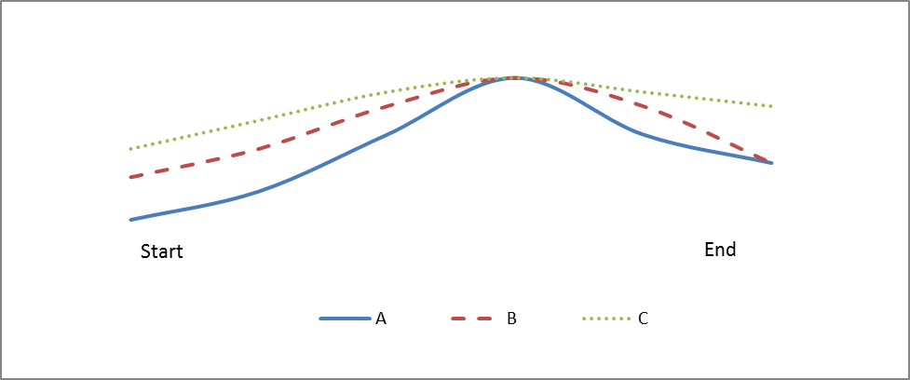

  - Based on the above profile, at what point did the crowd count take place? (Low, Med, Peak)

  - What share of customers would you consider are paying customers?

