Annie’s Farmers Market Performance Snapshot
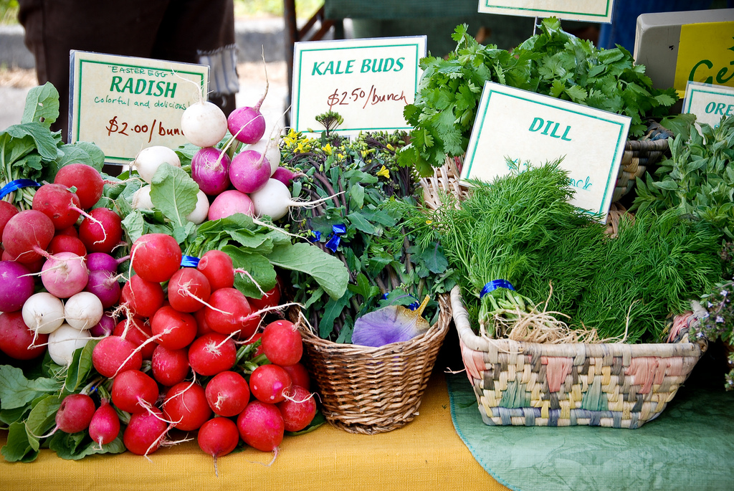
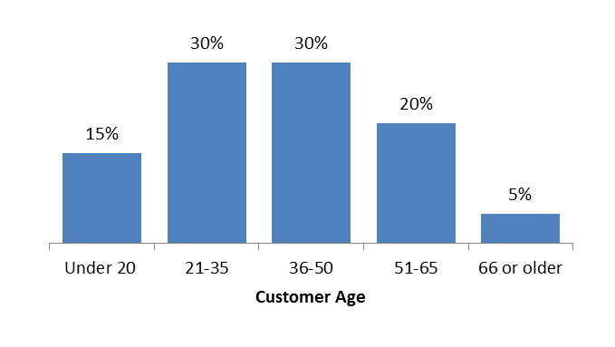
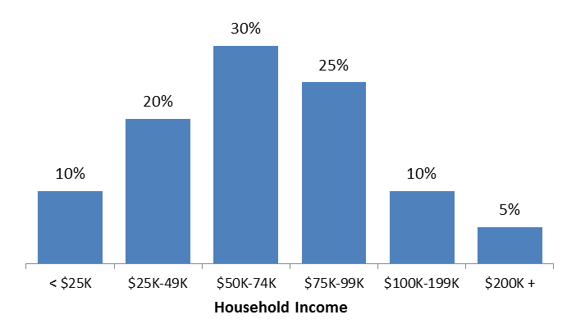
Market Mission/Vision:
- [MM#3]

Year Founded
Total annual customers: [CM#2]
Customers per market day: [CM#2]
Market days per year: [MM#2]
Manager names:
Average daily stall fee: [MM#2]

Customer Demographics
Narrative about who attends the market

Customer Loyalty & Retention
Percentage of customers who agree or strongly agree the farmers’ market provides the following community benefits.

[CS#5]

Vendor turnover rate: [MM#4]
Vendor growth rate: [MM#4]
Proportion of regular* vendors: [MM#4]
Registered vendors: [MM#4]
Average number of vendors: [MM#4]
*Regular vendors attend the market most weeks.

The Market Numbers
Photo: BC Association of Farmers’ Markets
Describe and Interpret customer loyalty [CS#1] and shopping frequency [CS#2]
1/2
Deficit/Surplus: [MM#1]
Revenue Growth: [MM#1]

MM#1
CS#17
CS#18
CS#13
[CS#4]
market

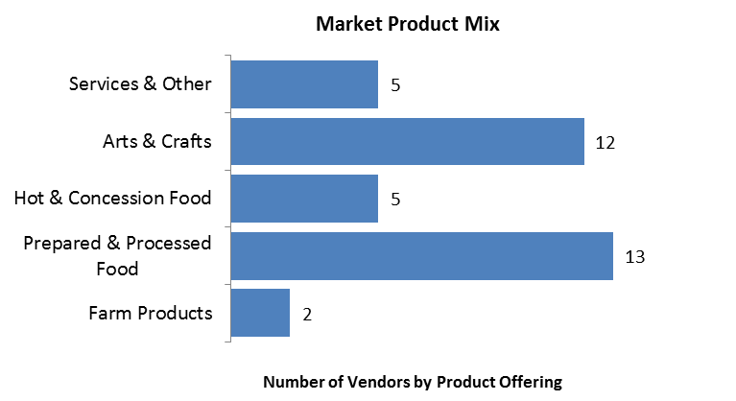


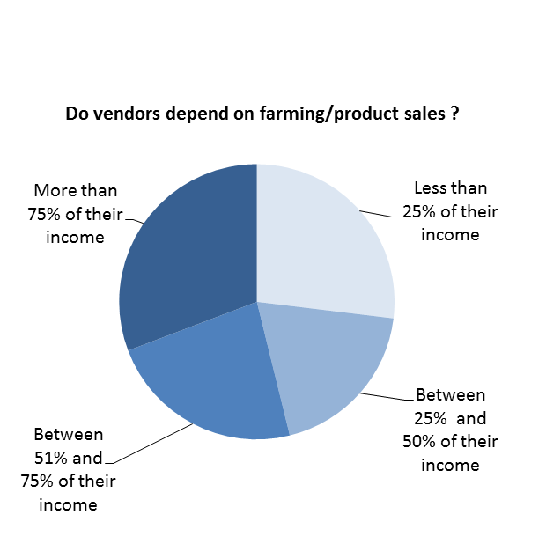
Vendor Attraction & Retention
Farmers’ Market Vendors Attract Dedicated Customers

[CS#3]

[VS#11]
.
Narrative about what vendors get out of the market based on:
[VS#5] [VS#6] [VS#12]
[MM#9]

Annie’s Farmers Market Performance Snapshot

Description and interpretation of [CS#9]
2/2
[MM#3, and interpretation of conclusions from graph above.]
What does the Farmers’ Market add to Vendor Businesses
VS#3
VS#9
VS#4

