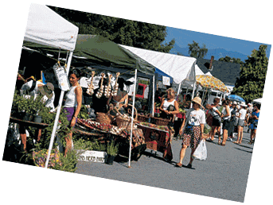
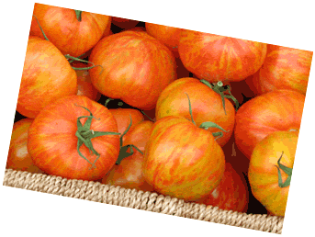

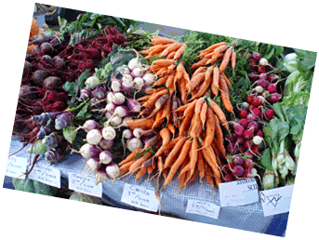
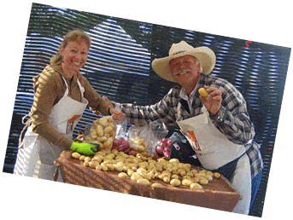

[Name of Market]
Impact Snapshot
[Date]
We’ve assembled a portrait of how [name of market] builds community, supports food security and the local economy, based on customer, vendor interviews and surveys. For more information, contact Annie Smith at 250 234-5678. The data shown here are based on 26 customer surveys, 30 vendor surveys and records of the market manager.

Photos: BC Association of Farmers’ Markets

Community Building
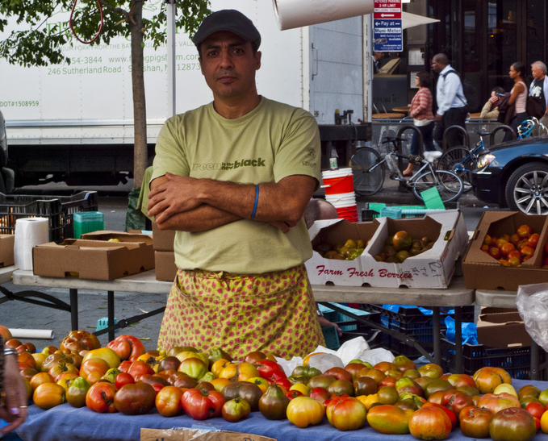
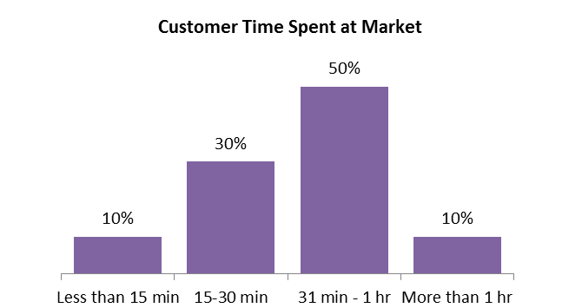
The Market as a Community Hub
CS#14]

(from surveys of customers)

Active Public Spaces Build Community
[CS#10]

- [CM#4]

Market Partner Organizations:
- [MM#12]

The Farmers’ Market is a Social Hub
Buying at the Farmers’ Market Builds Trust and Transparency
[MM#10b]

[ES#4]
[ES#5]
The Market Engages Local Business
Why do people love the experience of the farmers’ market?
- [CS#14]
- [ES#3]
- [VS#6]

(from surveys of customers and local stakeholders)
)
[CS#14]

CS#9
2/4
1/2
Economic Benefits
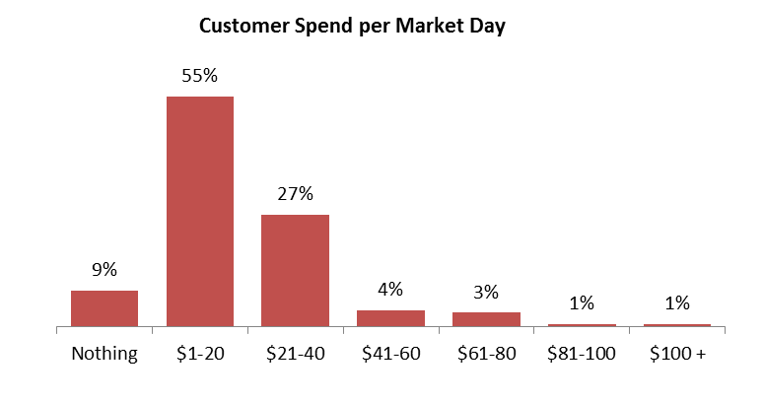
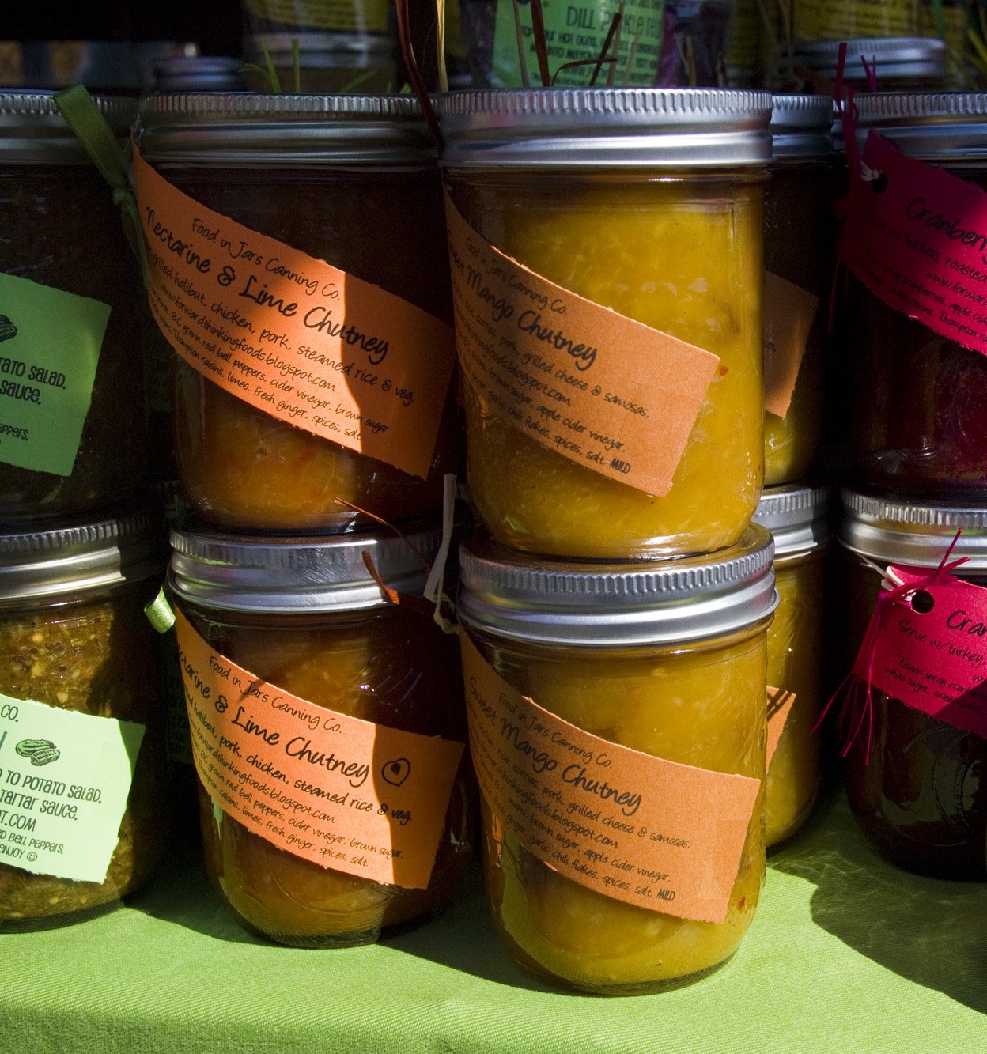
Annie’s Farmers’ Market is a dynamic marketplace for vendors to sell their goods. Beyond acting as a dynamic marketplace, farmers markets drive activity at other local businesses. The market employs local and stimulate networks of purchasing and producing within the local systems.
[VS#9]

Description and interpretation of: [MM#13]

Market Spending
Businesses take root and grow
[CS#3]
[MM#2]
[MM#2]

Buying at the Farmers’ Market Directly Supports Vendors / Local Farmers
Other local distribution methods are important for vendors to sell their products. Sales at the market are one type of product sale. Product sales are one type of farming revenue. Many farmers hold other jobs that make up their household revenue.

[VS#21]
Other important local sales channels are CSA shares, restaurant sales, and retail sales.
Support local farmers and other players in the local food system by buying at farmers’ markets and other local sales channels
VS#21
[CS#3]
3/4
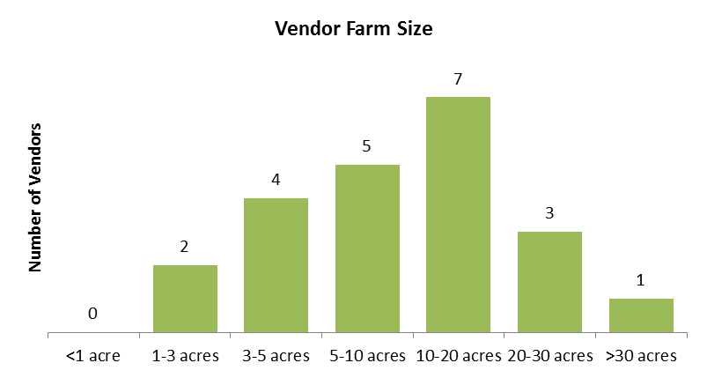
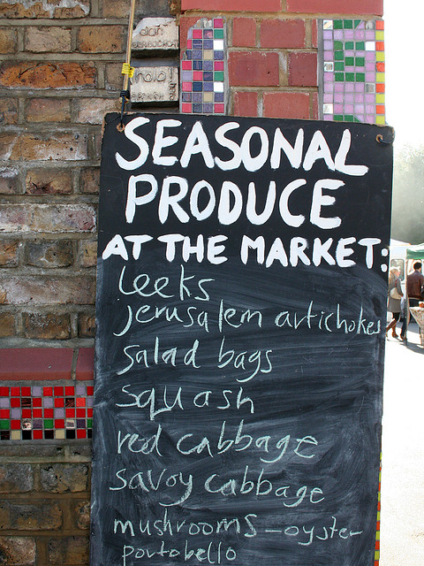


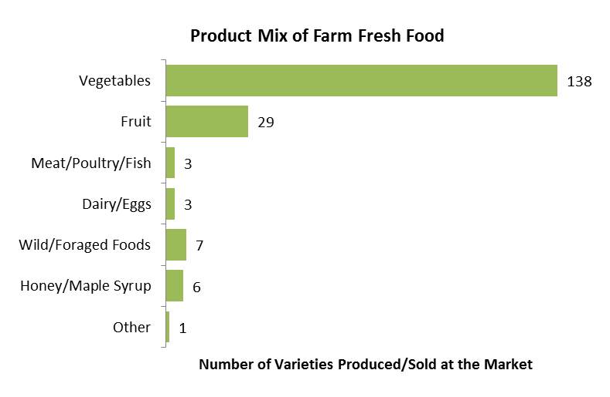
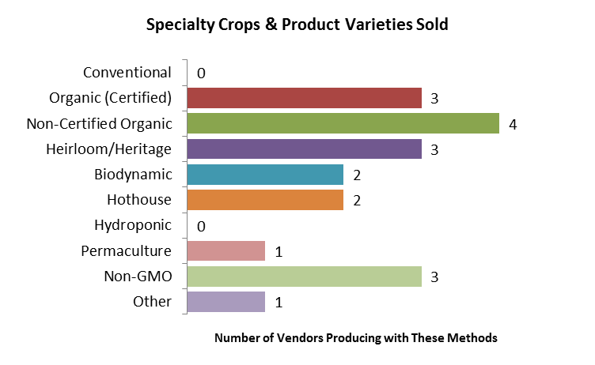
Produce varieties offered at the market:
- [VS#13]

Food Security and Sustainability
4/4
Photo: BC Association of Farmers’ Markets
The Markets Play an Important Role in Local and Regional Development
[The name of your] Market is included in regional food, agriculture and economic development plans:
- [MM#11]

Promoting Biodiversity and Supporting Local Farmland
Countless species of plants and animals are becoming extinct each year, which has immediate and profound effects on the sustainability of a balanced ecosystem. The farmers’ market is often the only place for vendors to sell specialty items that have little mass market appeal but are valuable contributions to maintaining the biodiversity essential to maintaining this balance. It is also the only place for many small-scale producers to sell their products, as local farmers are often unable to afford distribution at a larger scale.
Certifications include:
- [VS#17]

[VS#17]

The Farmers’ Market Promotes Sustainable, Responsible Agricultural Practices
Average vendor distance traveled to market: [VS#20]
Maximum distance traveled: [VS#20]

[VS#20]

The Farmers’ Market Supports Small Scale Agriculture
VS#19b
VS#14
VS#16

