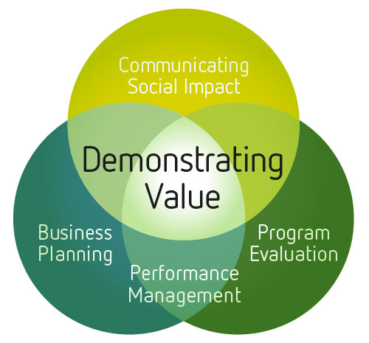 | WORKSHEET:  Identifying and Measuring Social Costs

Introduction
This worksheet is designed to help you identify and measure social costs, which are premiums or additional costs incurred above and beyond normal business costs due to the social, environmental or cultural mandate of the enterprise. Identifying social costs can help with assessing business strategies and sustainability, comparing business performance to industry benchmarks, and to quantify the extra resources needed to support social objectives in order to make a case for government or funder investment in operating shortfalls

This concept is covered is covered in more detail in the Demonstrating Value Guide: ll l lFinancial Intelligence, A Guide for Social Enterprise. You can integrate these costs into the True Cost Picture Workbook, an Excel spreadsheet that provides a step-by-step process for “adjusting” existing financial records to present a “double bottom line” picture of enterprise performance. These tools are available in the Tools and Resources section of the Demonstrating Value website (www.demonstratingvalue.org)

How to Identify your Social Costs
A worksheet is provided at the end of this document to help you in identifying and quantifying your social costs. The worksheet can be completed by following these steps:

Step 1
Brainstorm and define types of social costs that are significant to your organization. This can be done by reviewing your own business and mission activities as well as your chart of accounts and considering which costs might have a social component. Be sure to involve the appropriate staff in this exercise including accounting and operations people. See the box below for prompts to help you with your brainstorming.

Step 2
Assess the likely magnitude of each social cost – its significance in terms of financial resources and importance to the program objectives.

Step 3
Outline the methodology that could be used to quantify the social cost and identify what additional information should be tracked to support measurement

Step 4
Consider the challenges associated with that method and determine if the social component of a cost can be reliably measured

Step 5
Decide which social costs to include your financial report. This will depend on the materiality of the cost and the degree of complexity and reliability of the methodology.

TIPS
- Principles to remember and apply – materiality, relevance, reliability
- Don’t get caught up in identifying costs that are not relevant to decision makers or may not make that much difference to your cost picture

The following prompts may help in identifying and estimating social costs:
- Did you give away or discount your product or service because of mandate?
- Do you have higher training and management costs by having to hire a greater number of people to meet your FTE staffing requirements (for example, if target employees may otherwise be subject to disability claw-backs)?
- Do employees receive personal support, attend counseling and support groups/activities on paid time?
- Do supervisory/management staff assist employees with personal issues?
- Do you have higher employee turnover?
- Are target employees on average less efficient at producing quality products/service?
- Do you have higher absenteeism?
- Do you provide additional training for target employees to learn the job?
- Do you buy specific materials because they fit a certain mandate (specific to your mission)?
- Is there higher wastage of materials due to training or productivity cycles and issues?
- Does social enterprise management or staff spend a significant amount of time on issue advocacy?
- Is there an additional cost to where you are located, when that location was chosen because of community development; transit or walking access for employees?
- Do you need to pay higher insurance rates for certain types of employees?
- Are there any costs borne by outside organizations that are contributing to the success of your business? Even though it is beyond your capacity to track such costs, it is important to recognize and possibly disclose this information if there is a clear relationship and gain. (an example may be subsidized daycare offered to your employees by another community organization).

WORKSHEET:
Type Of Social Cost | Impact  (H-M-L) | Possible  Methodology | Reliable  Measure?  Y/N | Include?  Y/N
Eg. Allowance for employee inefficiency | High – significant factor in production and funding reliance | Standard labour and material usage per unit to be determined by operations manager based on trial tests and experience in business | Yes – can track actual v. expected material and labour per unit | Yes
Eg. Unearned Revenue – sales discounts provided to certain target groups | High – funders will want to see social benefits and how we are filling community needs | Based on prescribed discount rates and recorded at time of sale | Yes | Yes

