**Dashboard**

**Time Period**

*Prepared by:***Your Name**

Organization Name

**Goal / Objective1**

**Performance Narrative**

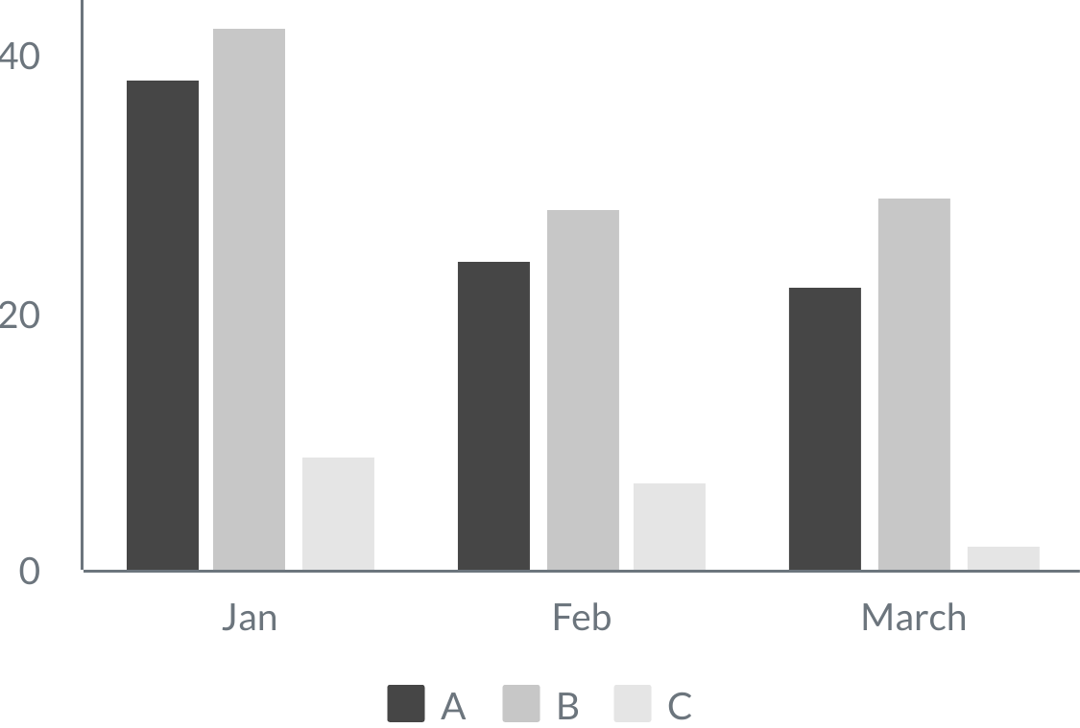

Date

Discussion of performance and impact not covered by numbers.

Interpretation of numbers.

Learning during the period and decisions based on evidence.

Next steps.

Display of a metric in more detail that could provide more insight into an issue that you are closely following.

**Deep Dive**

**Name of Indicator**

**10**

UNIT

Previous Period

**12%**

Target

**12**

**9**

**Name of Indicator3**

**12.3**

UNIT

Previous Period

Target

**12.3**

**12**

**Name of Indicator2**

**3**

UNIT

Previous Period

**33%**

Target

**4**

**6**

**Name of Indicator4**

**42**

UNIT

Previous Period

**8%**

Target

**39**

**100**

**Goal / Objective2**

**Name of Indicator5**

**3**

UNIT

Previous Period

**66%**

Target

**5**

**8**

**Name of Indicator6**

**187**

UNIT

Previous Period

Target

**183**

**N/A**

**Name of Indicator7**

**0.12**

UNIT

Previous Period

**-33%**

Target

**0.08**

**0.6**